TAUNTON DEANE BRIDLEWAYS ASSOCIATION (TDBA)
AGM Wednesday 31st Jan 2024 at 7PM
ZOOM VIRTUAL MEETING – opened at 19:00pm
Minutes

- APOLOGIES – none (Karen Slade joined 19:20)
- Present: Ann Finn, Lucy Squire, Domini Ricci, Karen Slade, Elaine Ravenscroft, Lucy Squire, Tricia Budd

- CHAIRMAN’S REPORT - Ann kindly provided with her report which will be included in the next newsletter.

- TREASURER’S REPORT- domini presented the 2023 accounts. Please see below snip as a summary. Anyone wanting more detail can request this from the TDBA

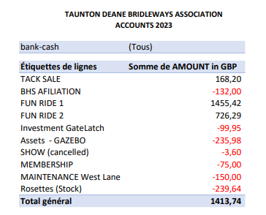
NB: Our membership funds were not transferred until after 31st Dec 2023 so sit in the 2024 accounts but were £320 total and our closing balance was £6102.71. It was commented that we completed a lot of work in 2023 but much of this was funded by other bodies so our spend for 2023 was less than expected. We have plans in 2024 for work which will include spend and are aware that the financial challenges in the Taunton council will likely mean we may need to fund more due to this.

- ELECTION OF CHAIRMAN Ann Finn stood in position again and there were no other interested parties to stand

- ELECTION OF COMMITTEE
Dominique stood as Treasurer, Lucy stood as Secretary (Both willing to continue from 2023 and there were no other parties interested to stand).

Elaine proposed the Chairman, Treasurer and secretary as per the nominations above, on block. Karen seconded this on block.

Elaine and Karen were nominated as the committee support members. Ann proposed this and Lucy Seconded this.

- SUBSCRIPTION £10 FROM JANUARY 2024 (remaining same as 2023). Tricia confirmed our thoughts that our plans for ensuring that all entries to our events will be required to be members in 2024 would ensure they would then all be covered by the BHS insurance through TDBA affiliation. Lucy also commented that we may be able to use Membership Mojo to allow riders to register for the events which would then be able to include membership enrolment too.

- SUGGESTIONS FOR BRIDLEWAY IMPROVEMENTS THAT WE MIGHT HELP FUND and possible events
- Ann mentioned she would like to ensure that the surface on rodwell lane is secured and we may contribute to this cost of this.
- Karen would like to work on the improvement of the bridleway at Lydyard St Lawrence. This one currently has a number of very large potholes etc. This will be costly and may need to involve specific fund raising to support
- Tricia asked about the Herepath section which is near paddocks/ Curlands where there are some old tyres which were used under the path surface but soon poked through and so the path became unsafe and was closed off. The current land owner has been approached by the ROW lead and there is ongoing dialogue. Tricia also asked about Dairy house lane in a similar area which has been challenged for access. This is also owned by the same landowner as the Herepath issue.
- Ann also mentioned that we may look to offer some visits to Glenda Spooner farm and facilities; the police horses @ Clevedon for some opportunity for riding road safety courses. Also whether there are any local Mechanical horse faciity to hire/ book onto.

- AOB – date of next committee meeting agreed as 27th Feb, Tues 7pm Zoom.
Meeting closed at 20:18pm

